**XenonStack Assignment 1**

Scenario There is a customer who came to you with a problem to have a custom linux command for his operations. Your task is to understand the problem and create a linux command via bash script as per the instructions.

File Structure  
  
 internsctl/

|-- bin/

| `-- internsctl

|-- man/

| `-- internsctl.1

|-- src/

| |-- cpu.sh

| |-- memory.sh

| |-- user.sh

| `-- file.sh

|-- internsctl

`-- README.md

We need to move the /bin/internsctl to /user/local/bin to make the file executable from any location of the machine.

**Screenshots**  
**Section A**  
  
1. man internstcl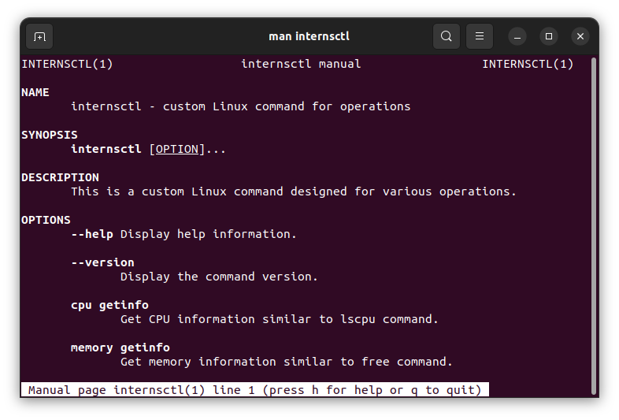

2. Internsctl –help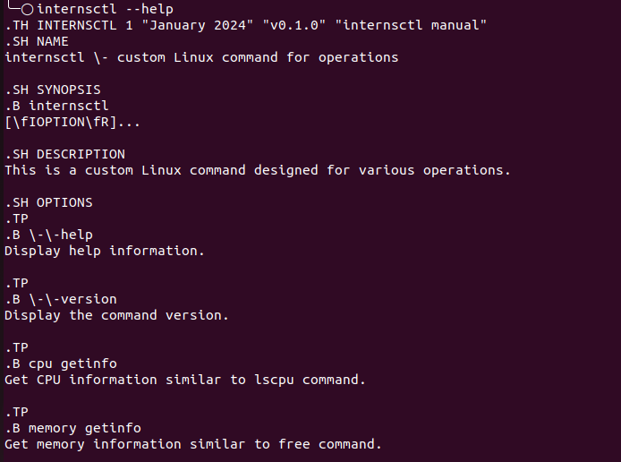  
  
3. Internsctl –version  
  


**Section B  
  
  
Part 1  
  
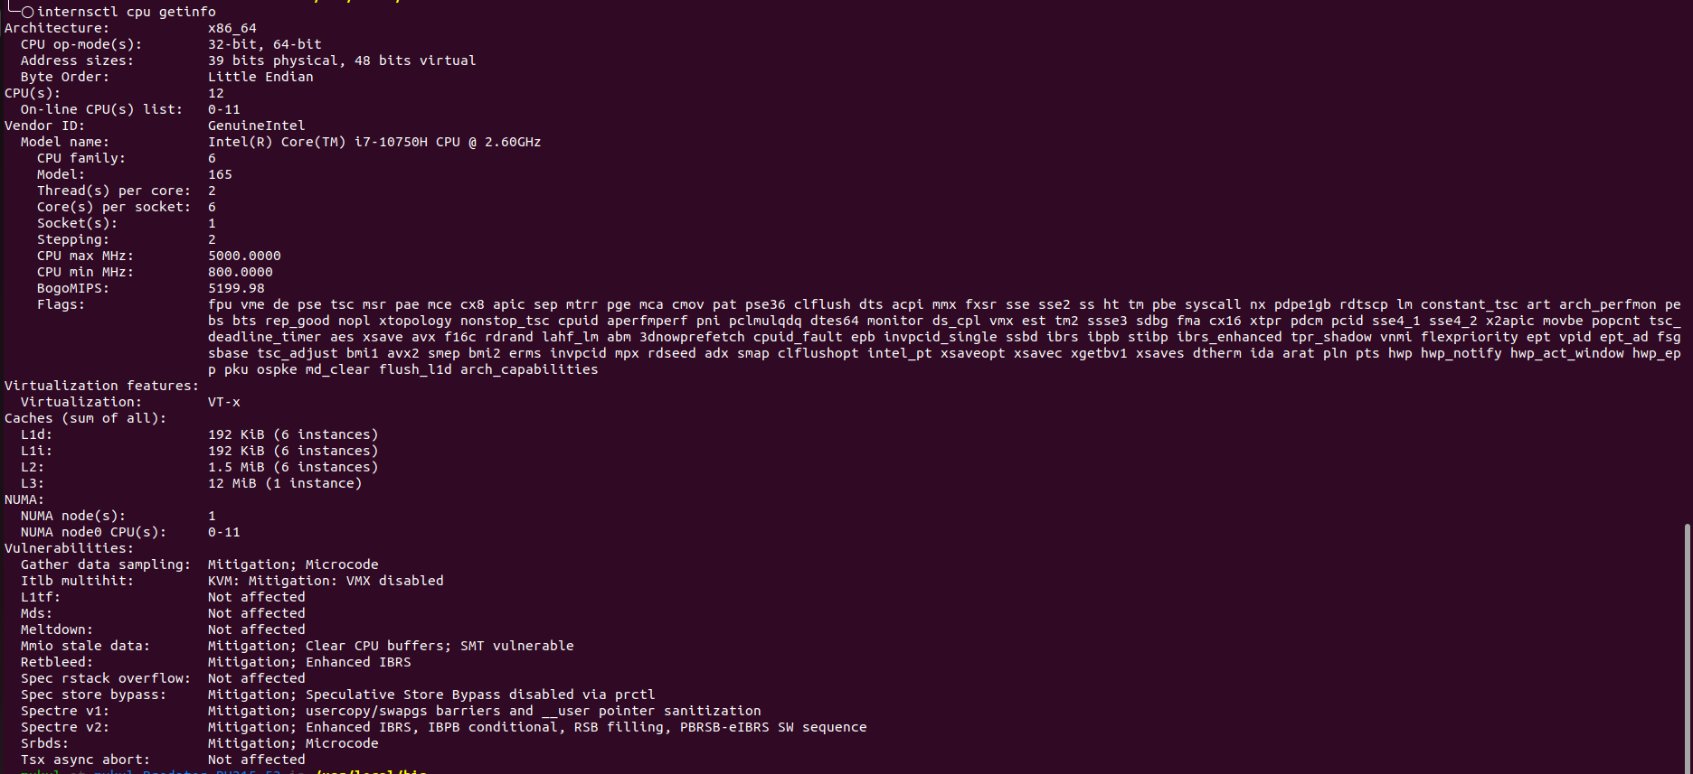  
  
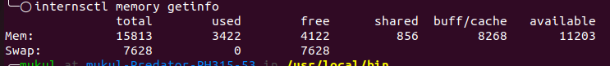  
  
  
  
Part 2**

**a.**

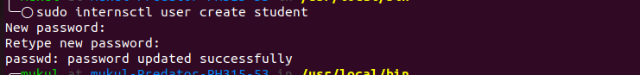

**b.**

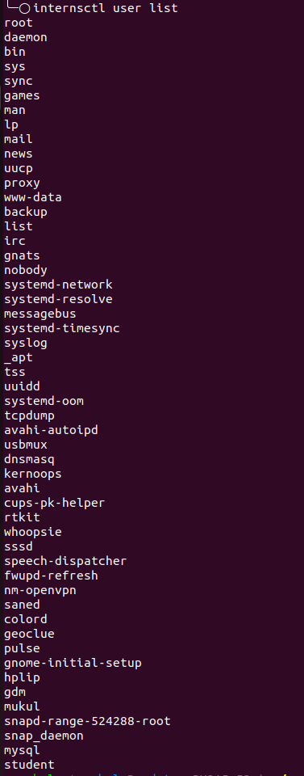

**C.**

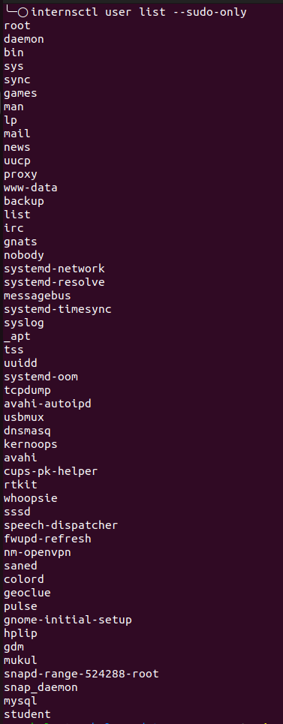

**Part 3**

**1.**

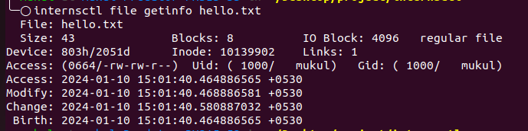

**2.**



**3.**



**4.**

**  
  
5.**

